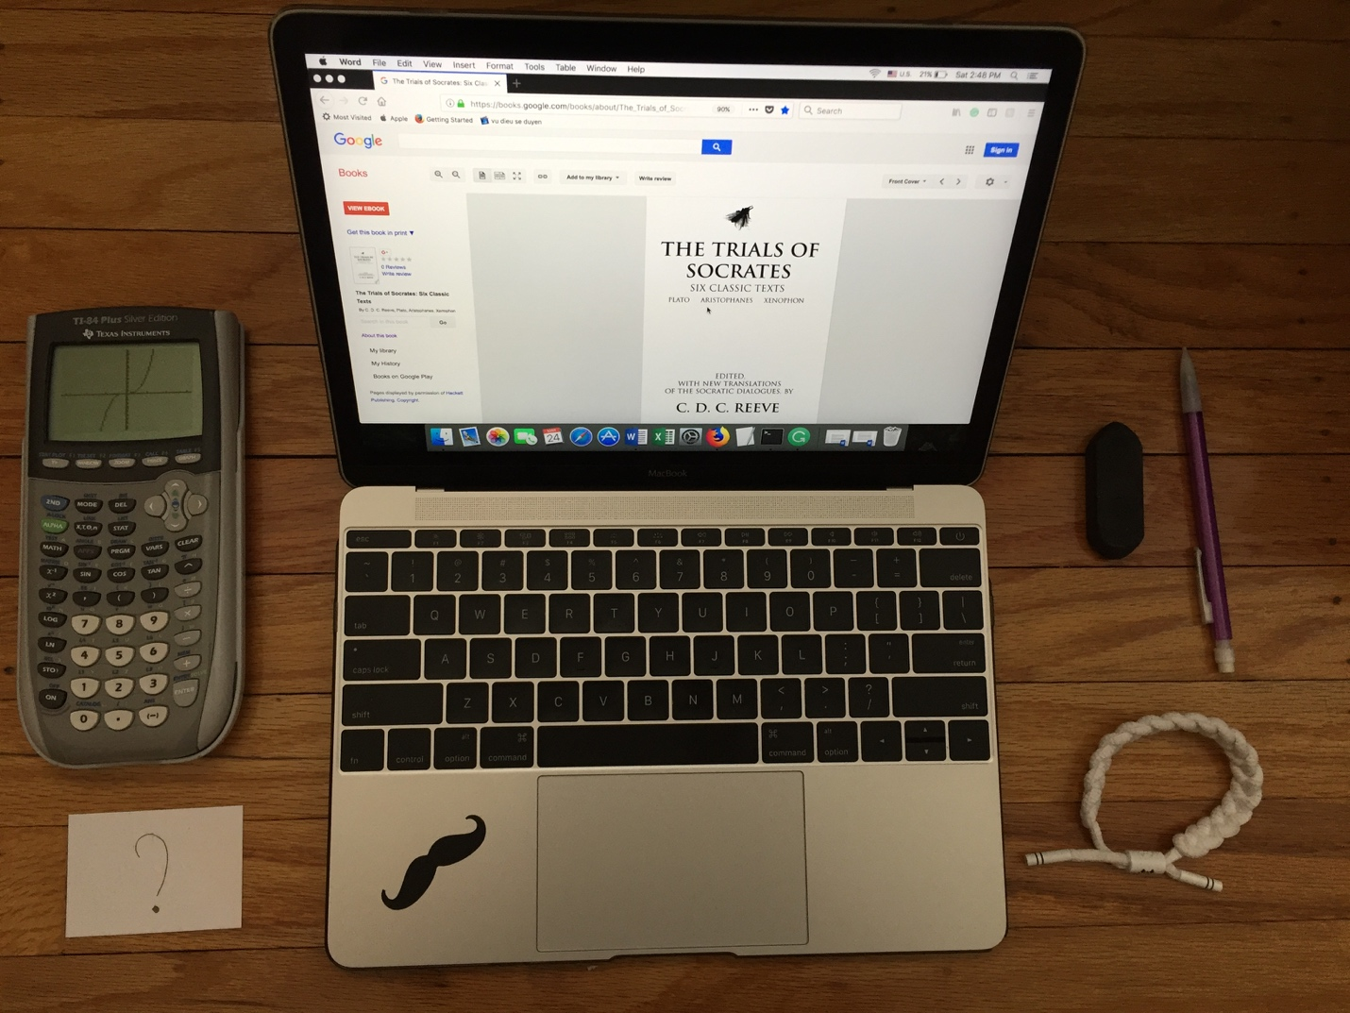

Tuan Nguyen

Book Bento for The Trials of Socrates: Six Classic Texts by C. D. C. Reeve

A calculator with the graph

The graph represents the timeline of Socrates’s life. Socrates is born in Athens, served as a hoplite in Athenian army. The concave-up part shows his royal period when he served as a hoplite in the Athenian army during the Peloponnesian War with Sparta. He gained attention for his courage and capacity to tolerate hunger, thirst, and cold. Since he is poor and owns no property, he often went barefoot and wore the same cloak winter and summer. The concave down part shows his disrupt period when he brought to trial on a charge of corrupting the youth by teaching them not believe in the gods. Moreover, he was found guilty but he claims that it is no different in practice or not practice a religion.

The postcard has the question mark

-Question mark shows Socrates personal characteristic of curiosity. Socrates claims that the charisma can be important as content. For instance, he mentions that if he has no certain compelling something, then who would have listened to him. He provides interest matters in his conversation, just to get people attention. He tried to influence others to believe in his idea is truly credible. However, later he would refuse his idea by showing the conflict and distinct from another idea. When Socrates is discussed on a subject, he can be controversial and compelling at the same time. For example, Socrates questioned Euthyphro about is the pious loved by gods or it is pious because it’s loved. Socrates constantly questioned Euthyphro on ethical virtues of things being led or leading to make Euthyphro changes his belief in matters.

Pencil and Eraser

-Pencil and eraser shows the justice and moral belief of Euthyphro. Euthyphro, a prophet and self-proclaimed authority on Greek religion. He places justice over love when he prosecutes his own father on the trial for commit murder. Euthyphro’s action makes Socrates questions him on what is holiness. Socrates thinks that Euthyphro’s perspective on the religious matter can help him in the trial against Meletus. Euthyphro as dogmatically religious man believes that either his father or anyone else who commit a crime must be charged. However, Socrates opposes to Euthyphro’s idea that moral belief can be over justice. Socrates does not believe in any religion opposes on Euthyphro justice is unsuitable when he turns his own father on trial.

Wristband

-A wristband represents how Euthyphro and Socrates are opposite in personalities and religious beliefs. Euthyphro is described as an expert in religious matters. On the other hand, Socrates is illustrated as anti-religious. He claims that he is knowledgeable about any subject. However, Socrates is speaking in a plain and confusing argument, which makes Euthyphro thinks that Socrates is a fool. For instance, Socrates asked Euthyphro a ton of questions about thing’s being carried or carrying, led or leading, and seen or seeing. Socrates can be a genius or an idiot at some point in his conversation to Euthyphro’s perspective.

Computer

-An eBook version of the book.